1-bit RAM — RTL Schematic
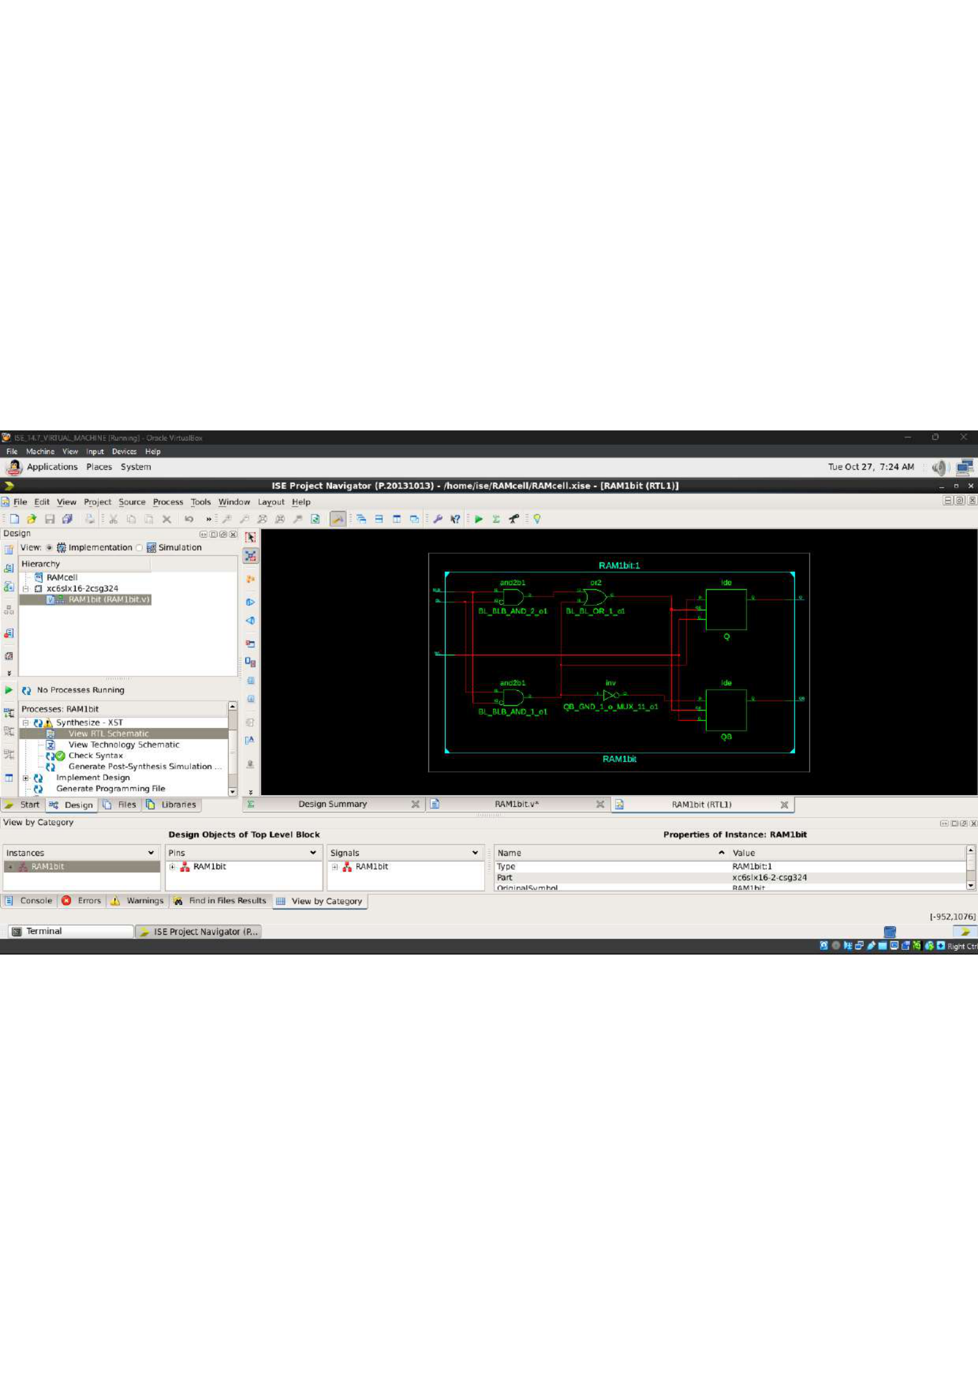

1-bit RAM — VHDL Source Code
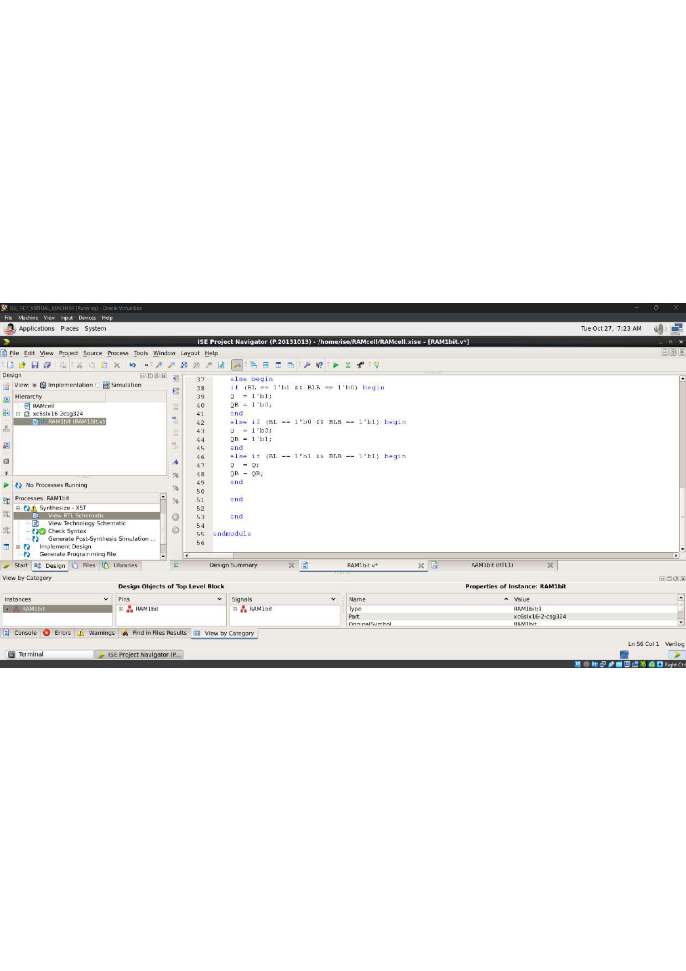

1-bit RAM — Project Hierarchy and Testbench
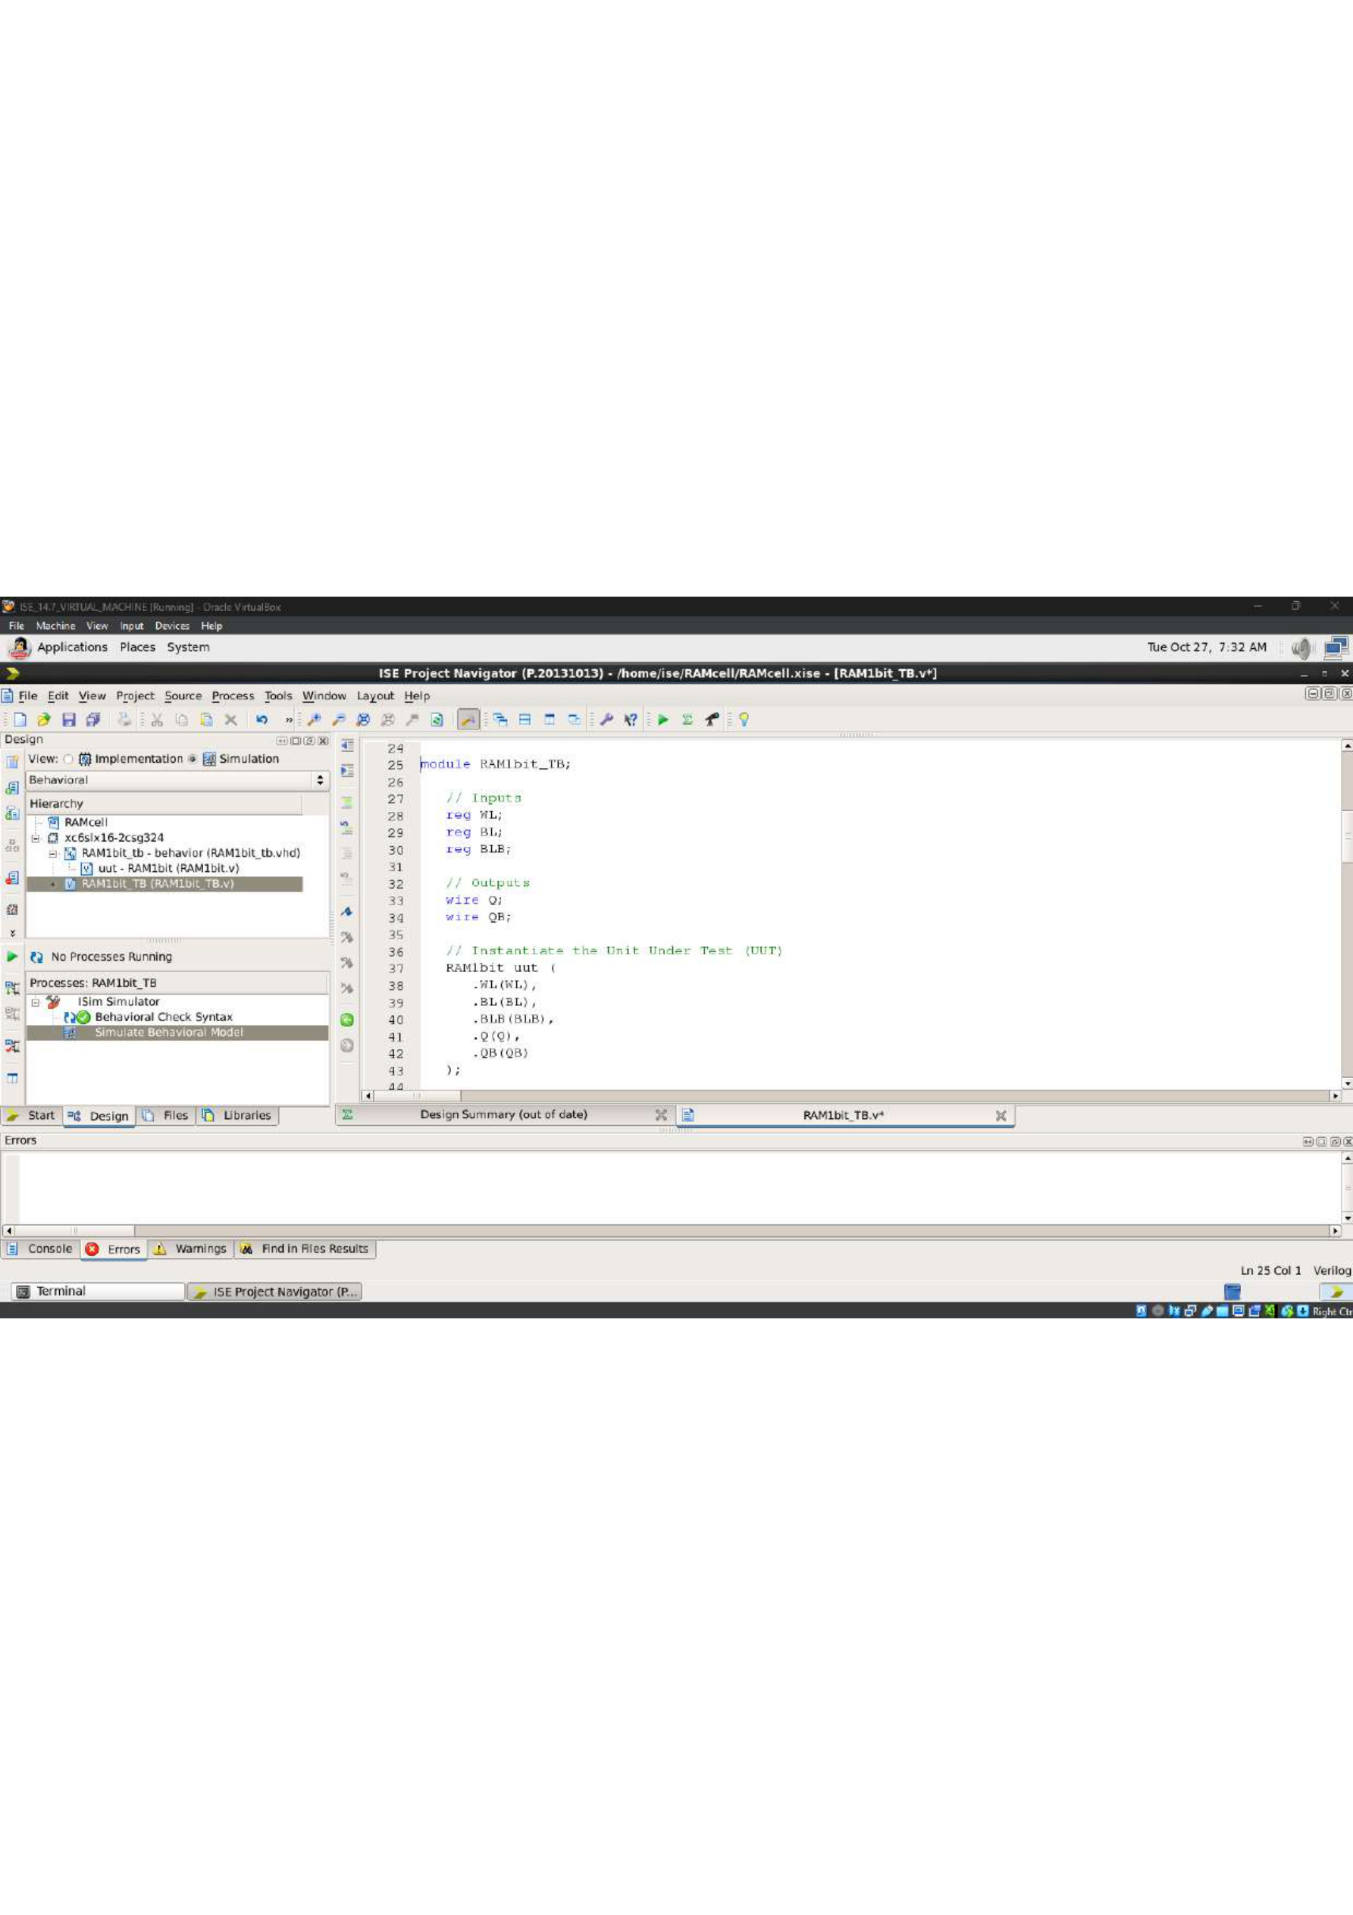

1-bit RAM — Simulation Waveform
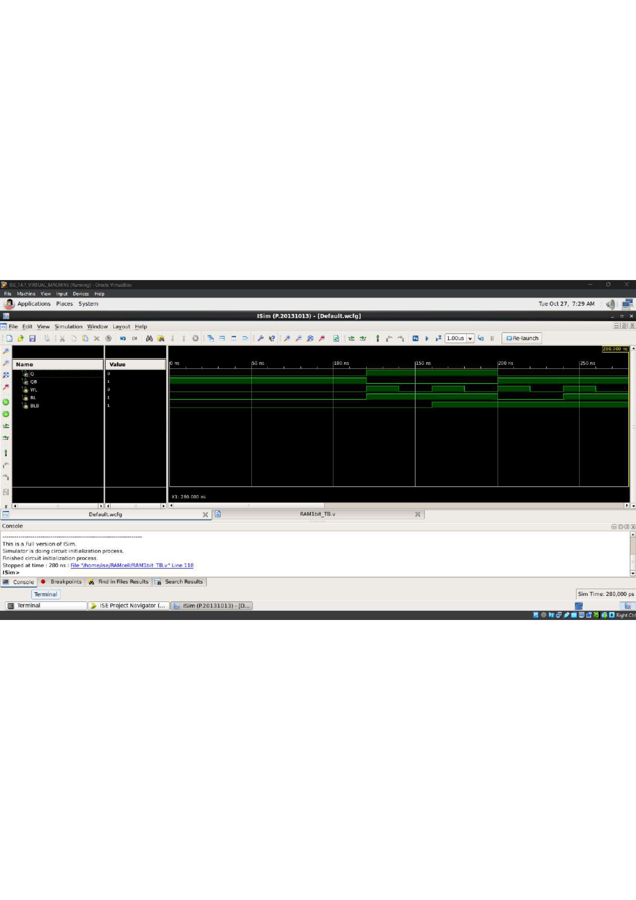

Asynchronous Up-Down Counter — RTL Schematic
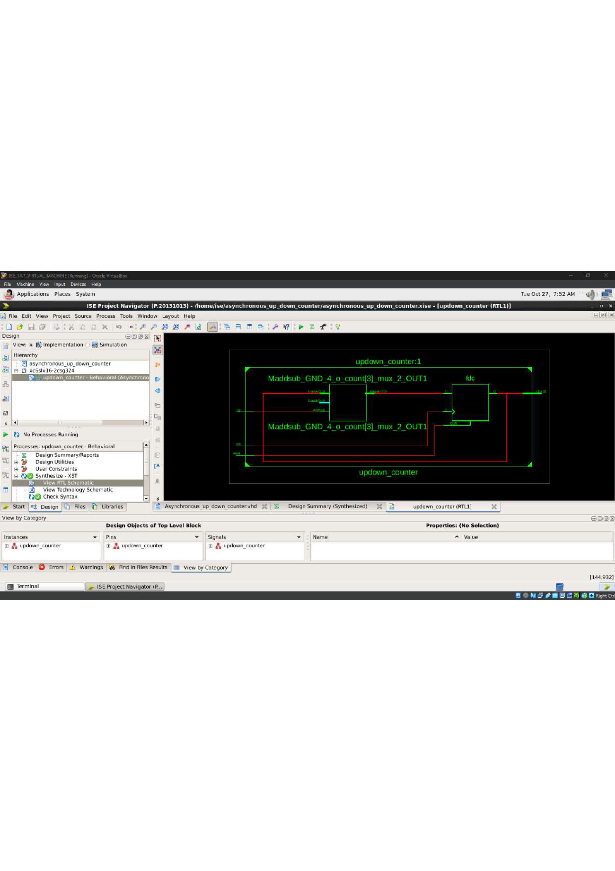

Asynchronous Up-Down Counter — VHDL Source Code
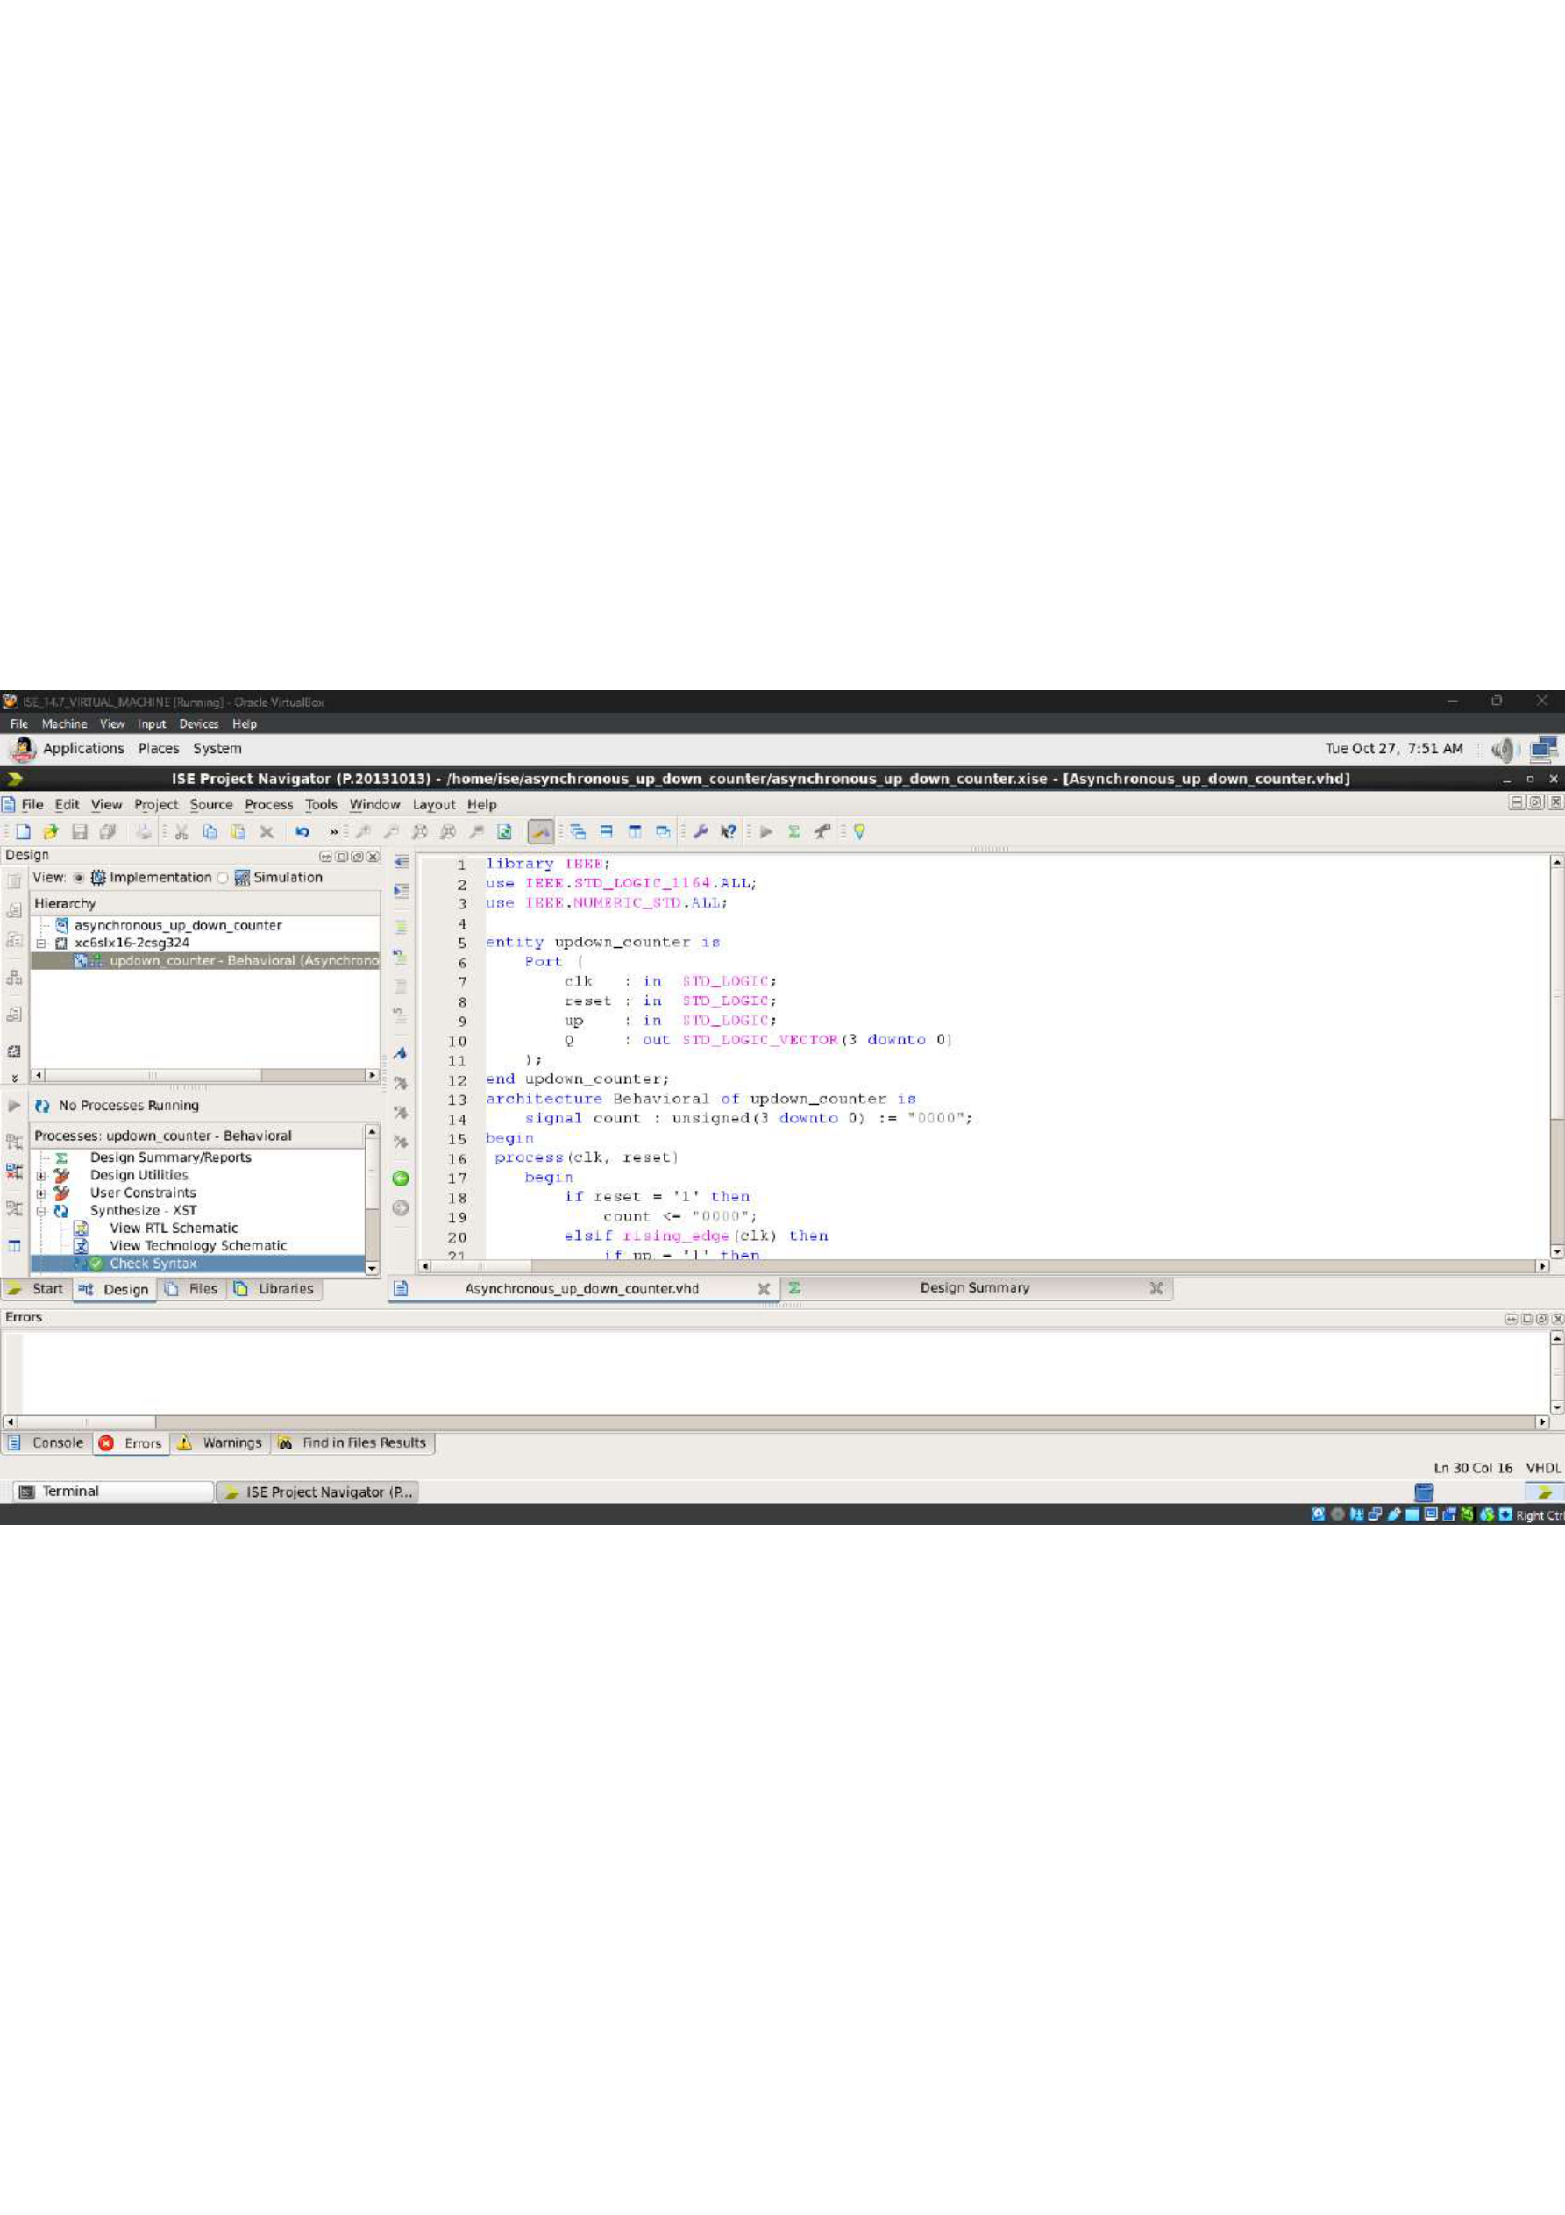

Up-Down Counter — Testbench / Simulation Setup
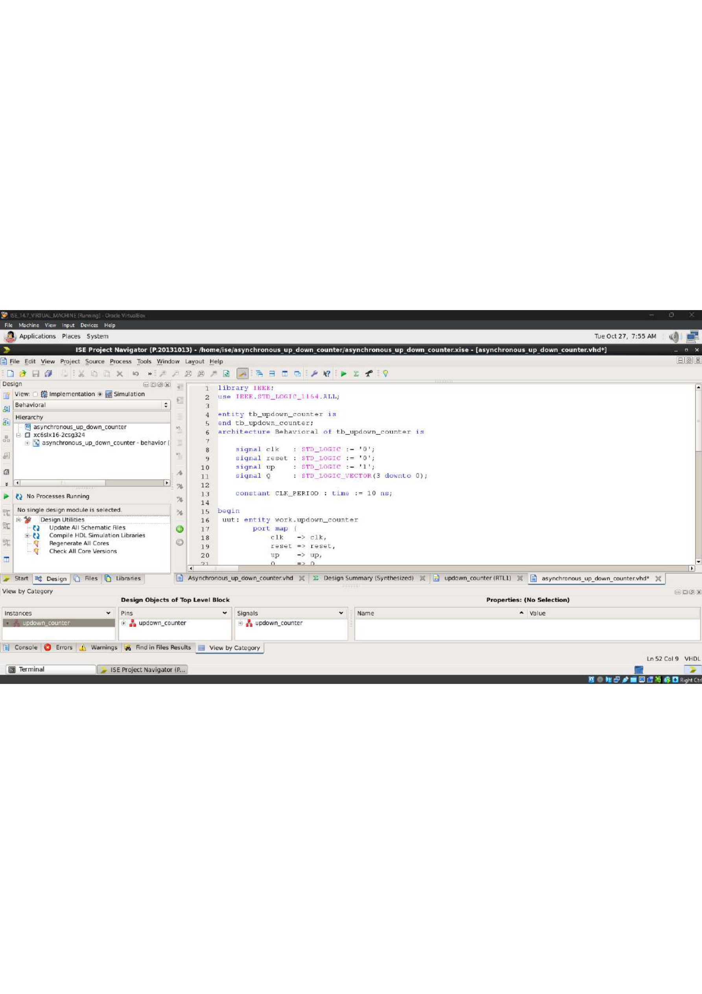

Up-Down Counter — Simulation Waveform
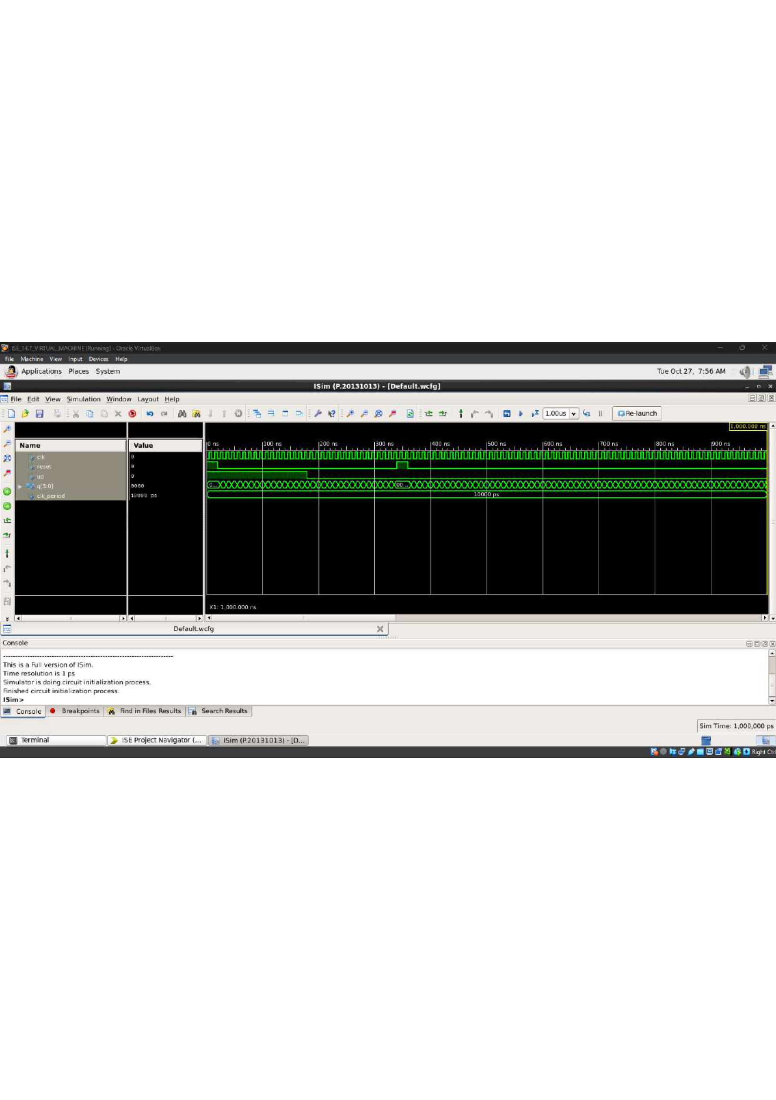

Parallel Adder — RTL Schematic
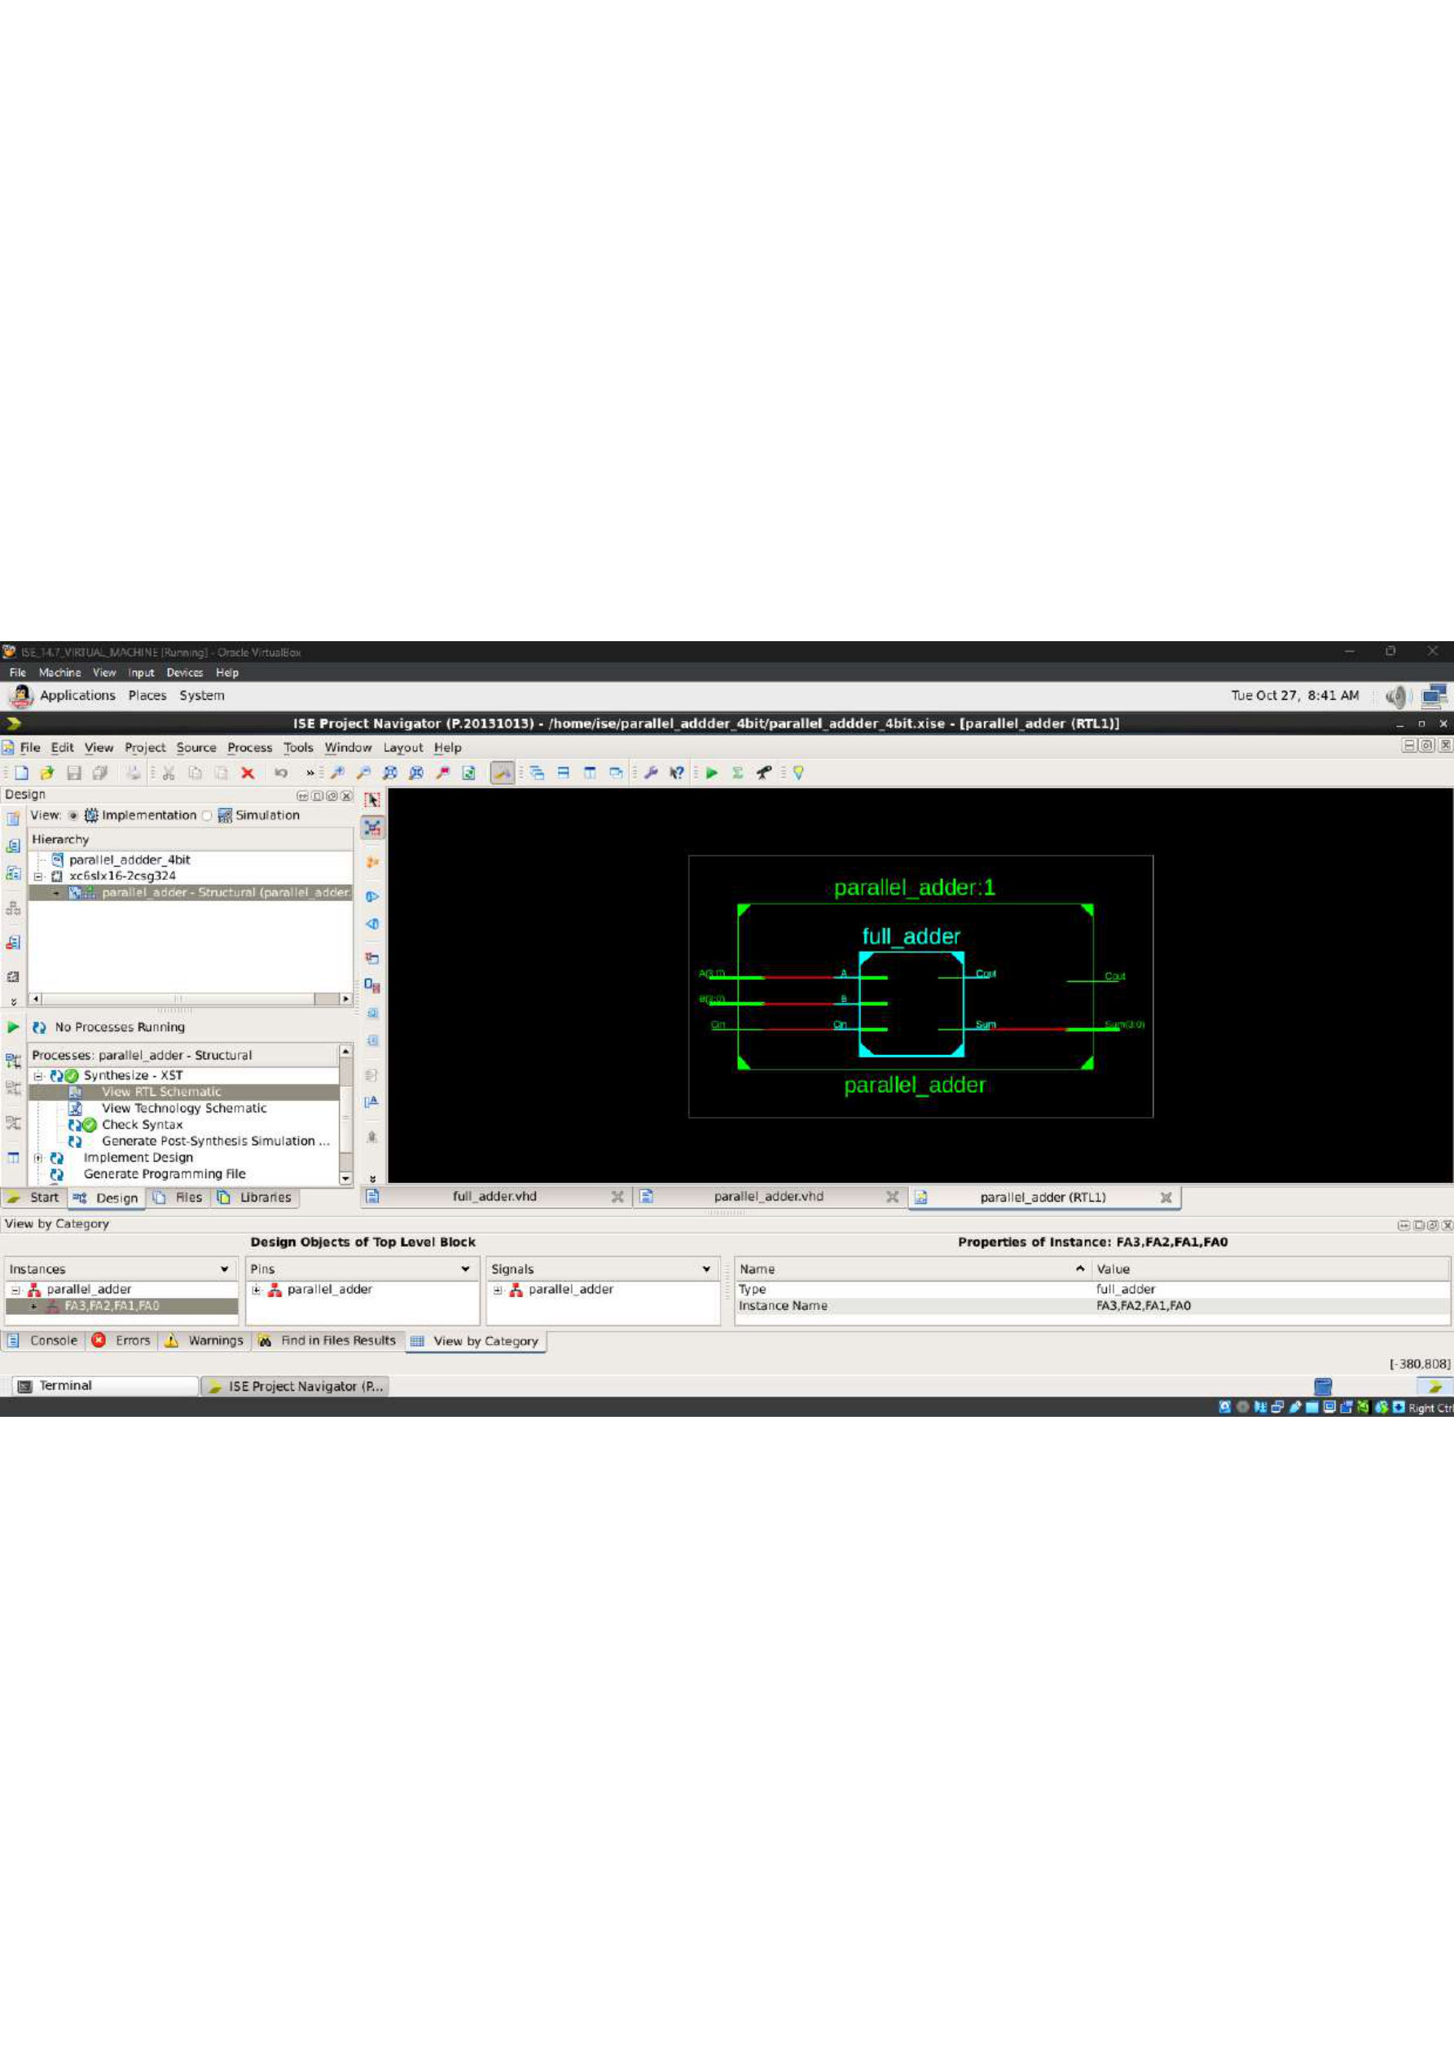

Parallel Adder — Structural VHDL Code
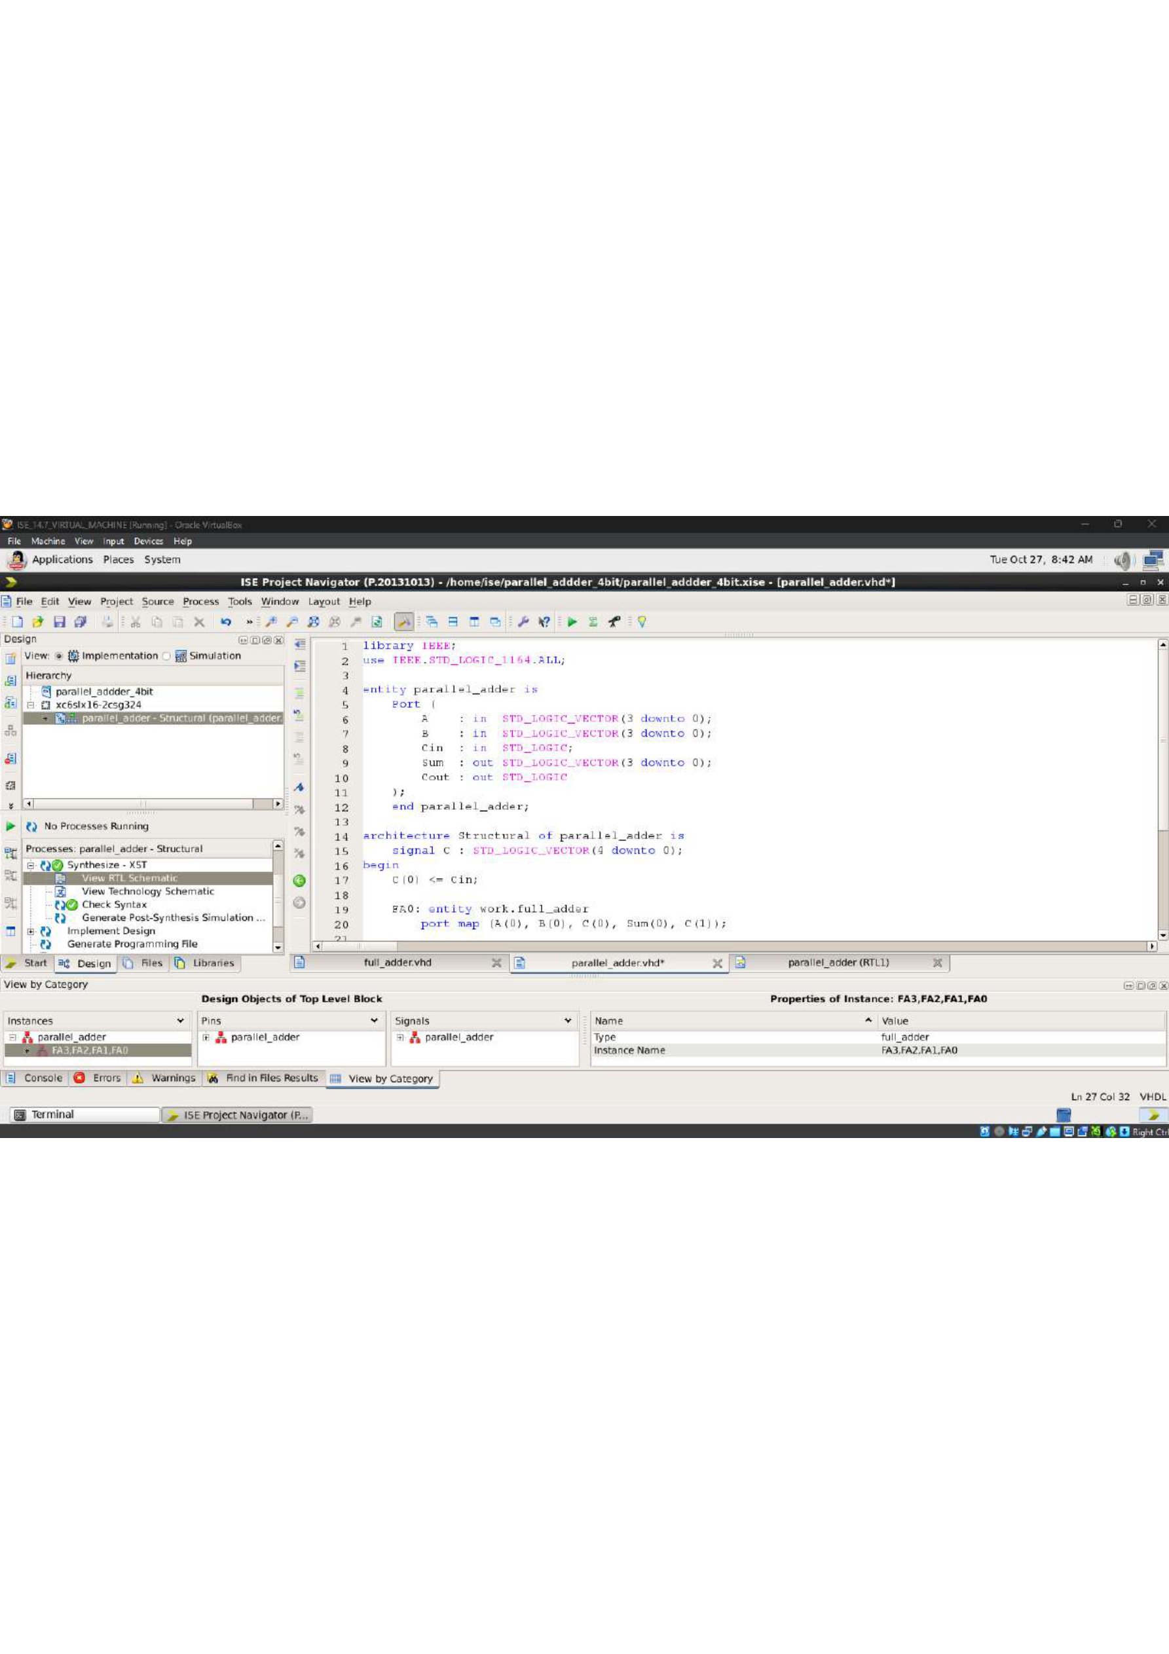

Parallel Adder — Testbench Code
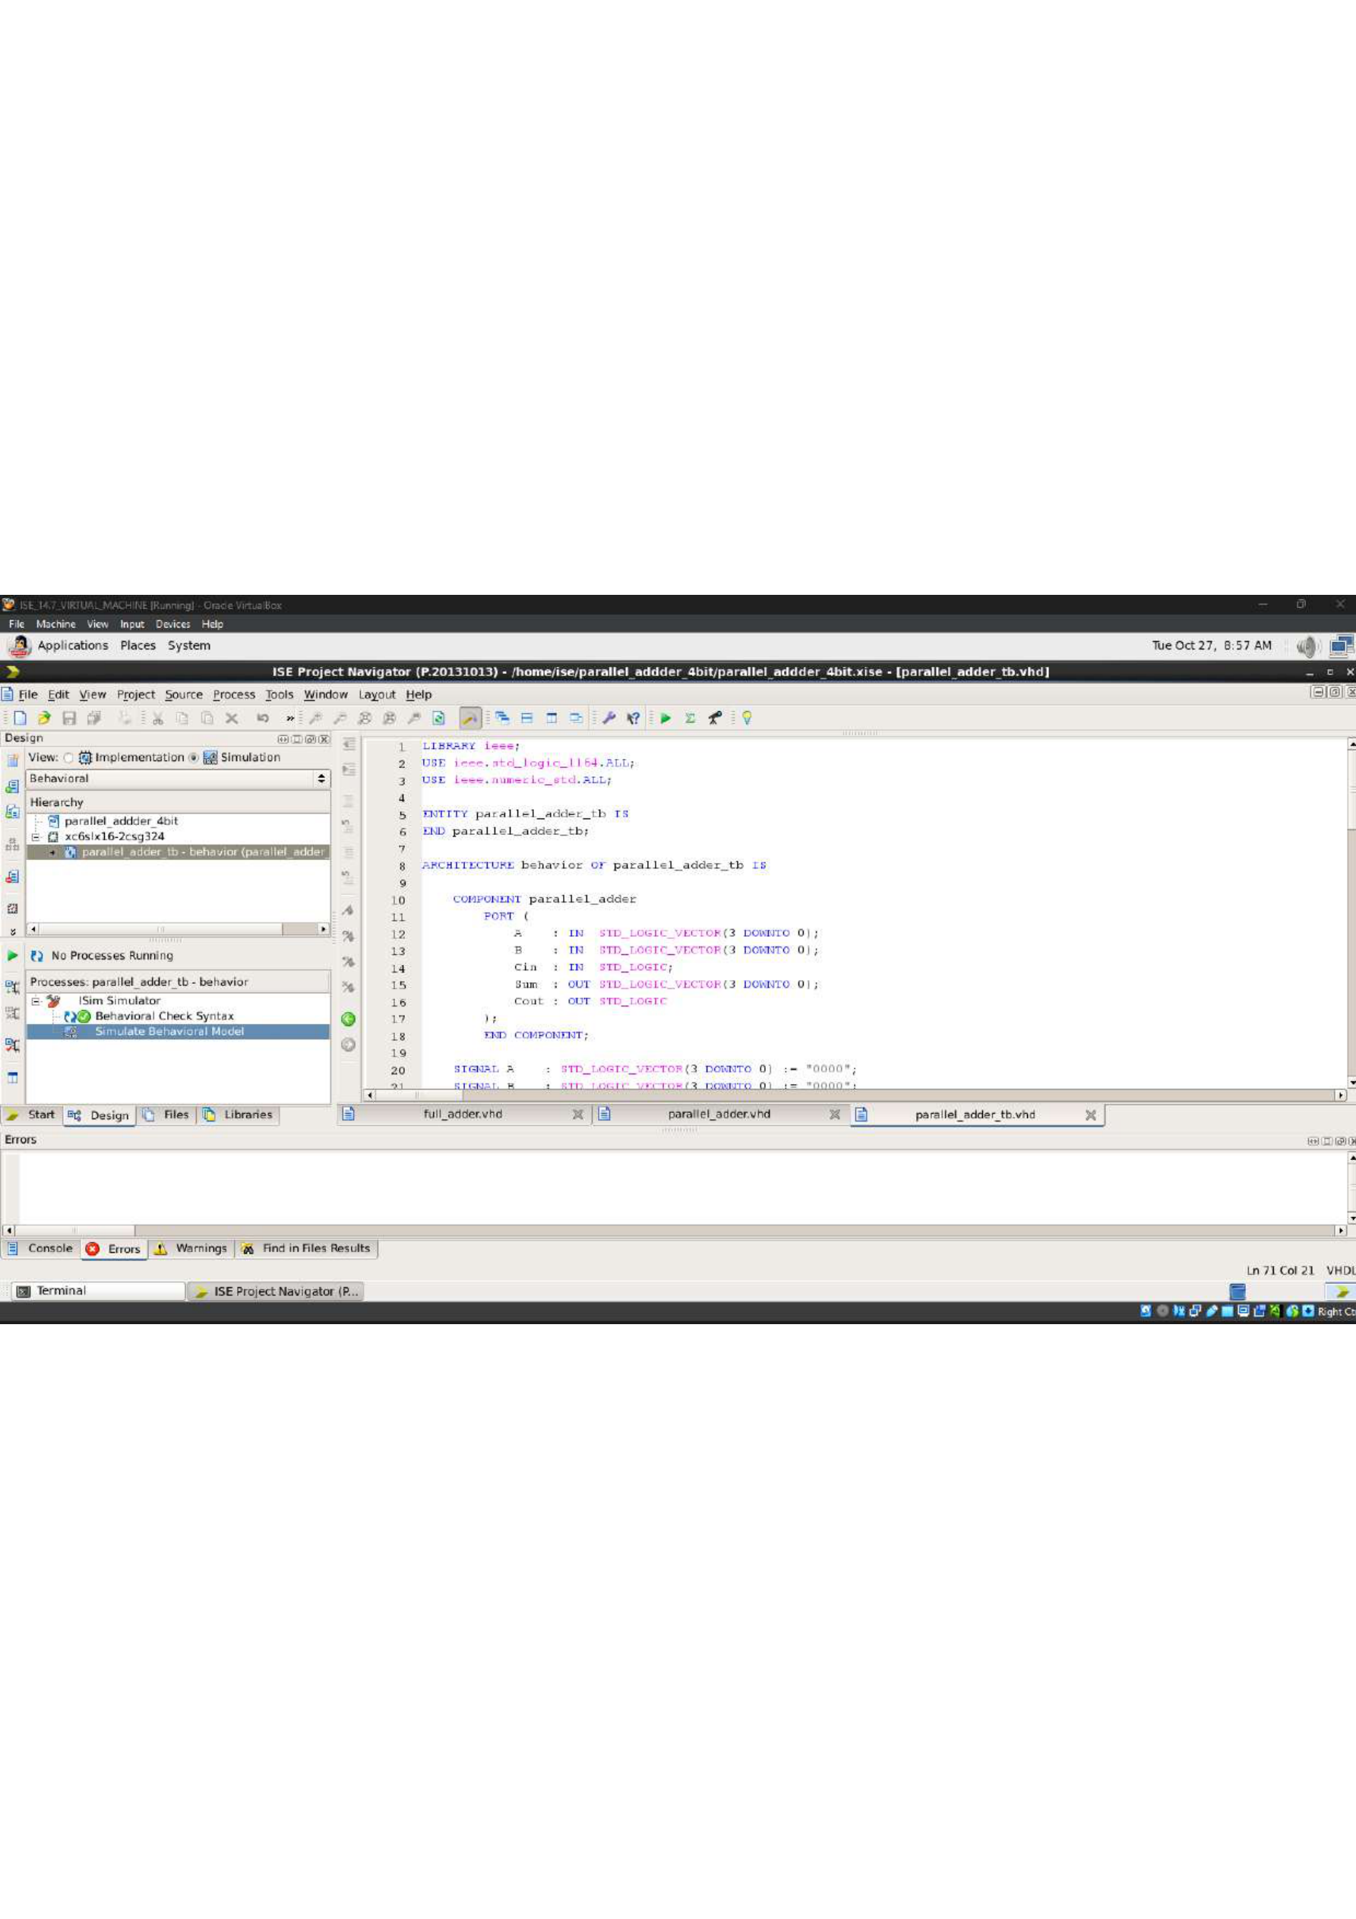

Parallel Adder — Simulation Waveform
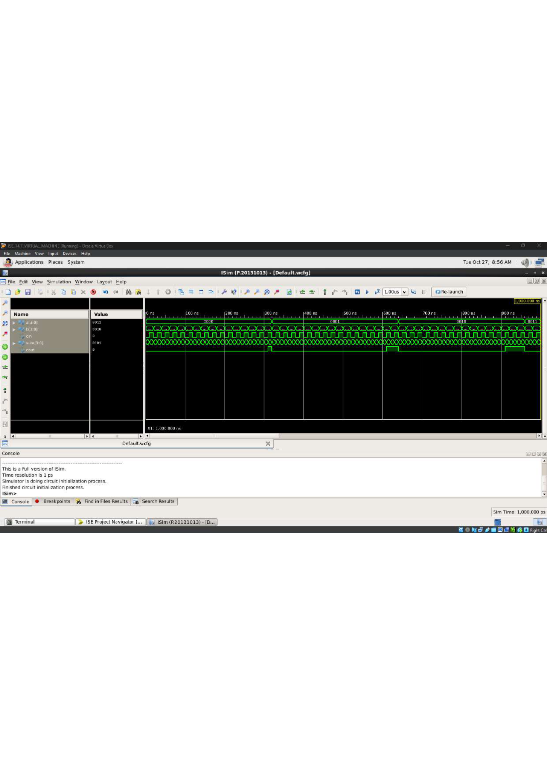

8×8 RAM — VHDL Source Code
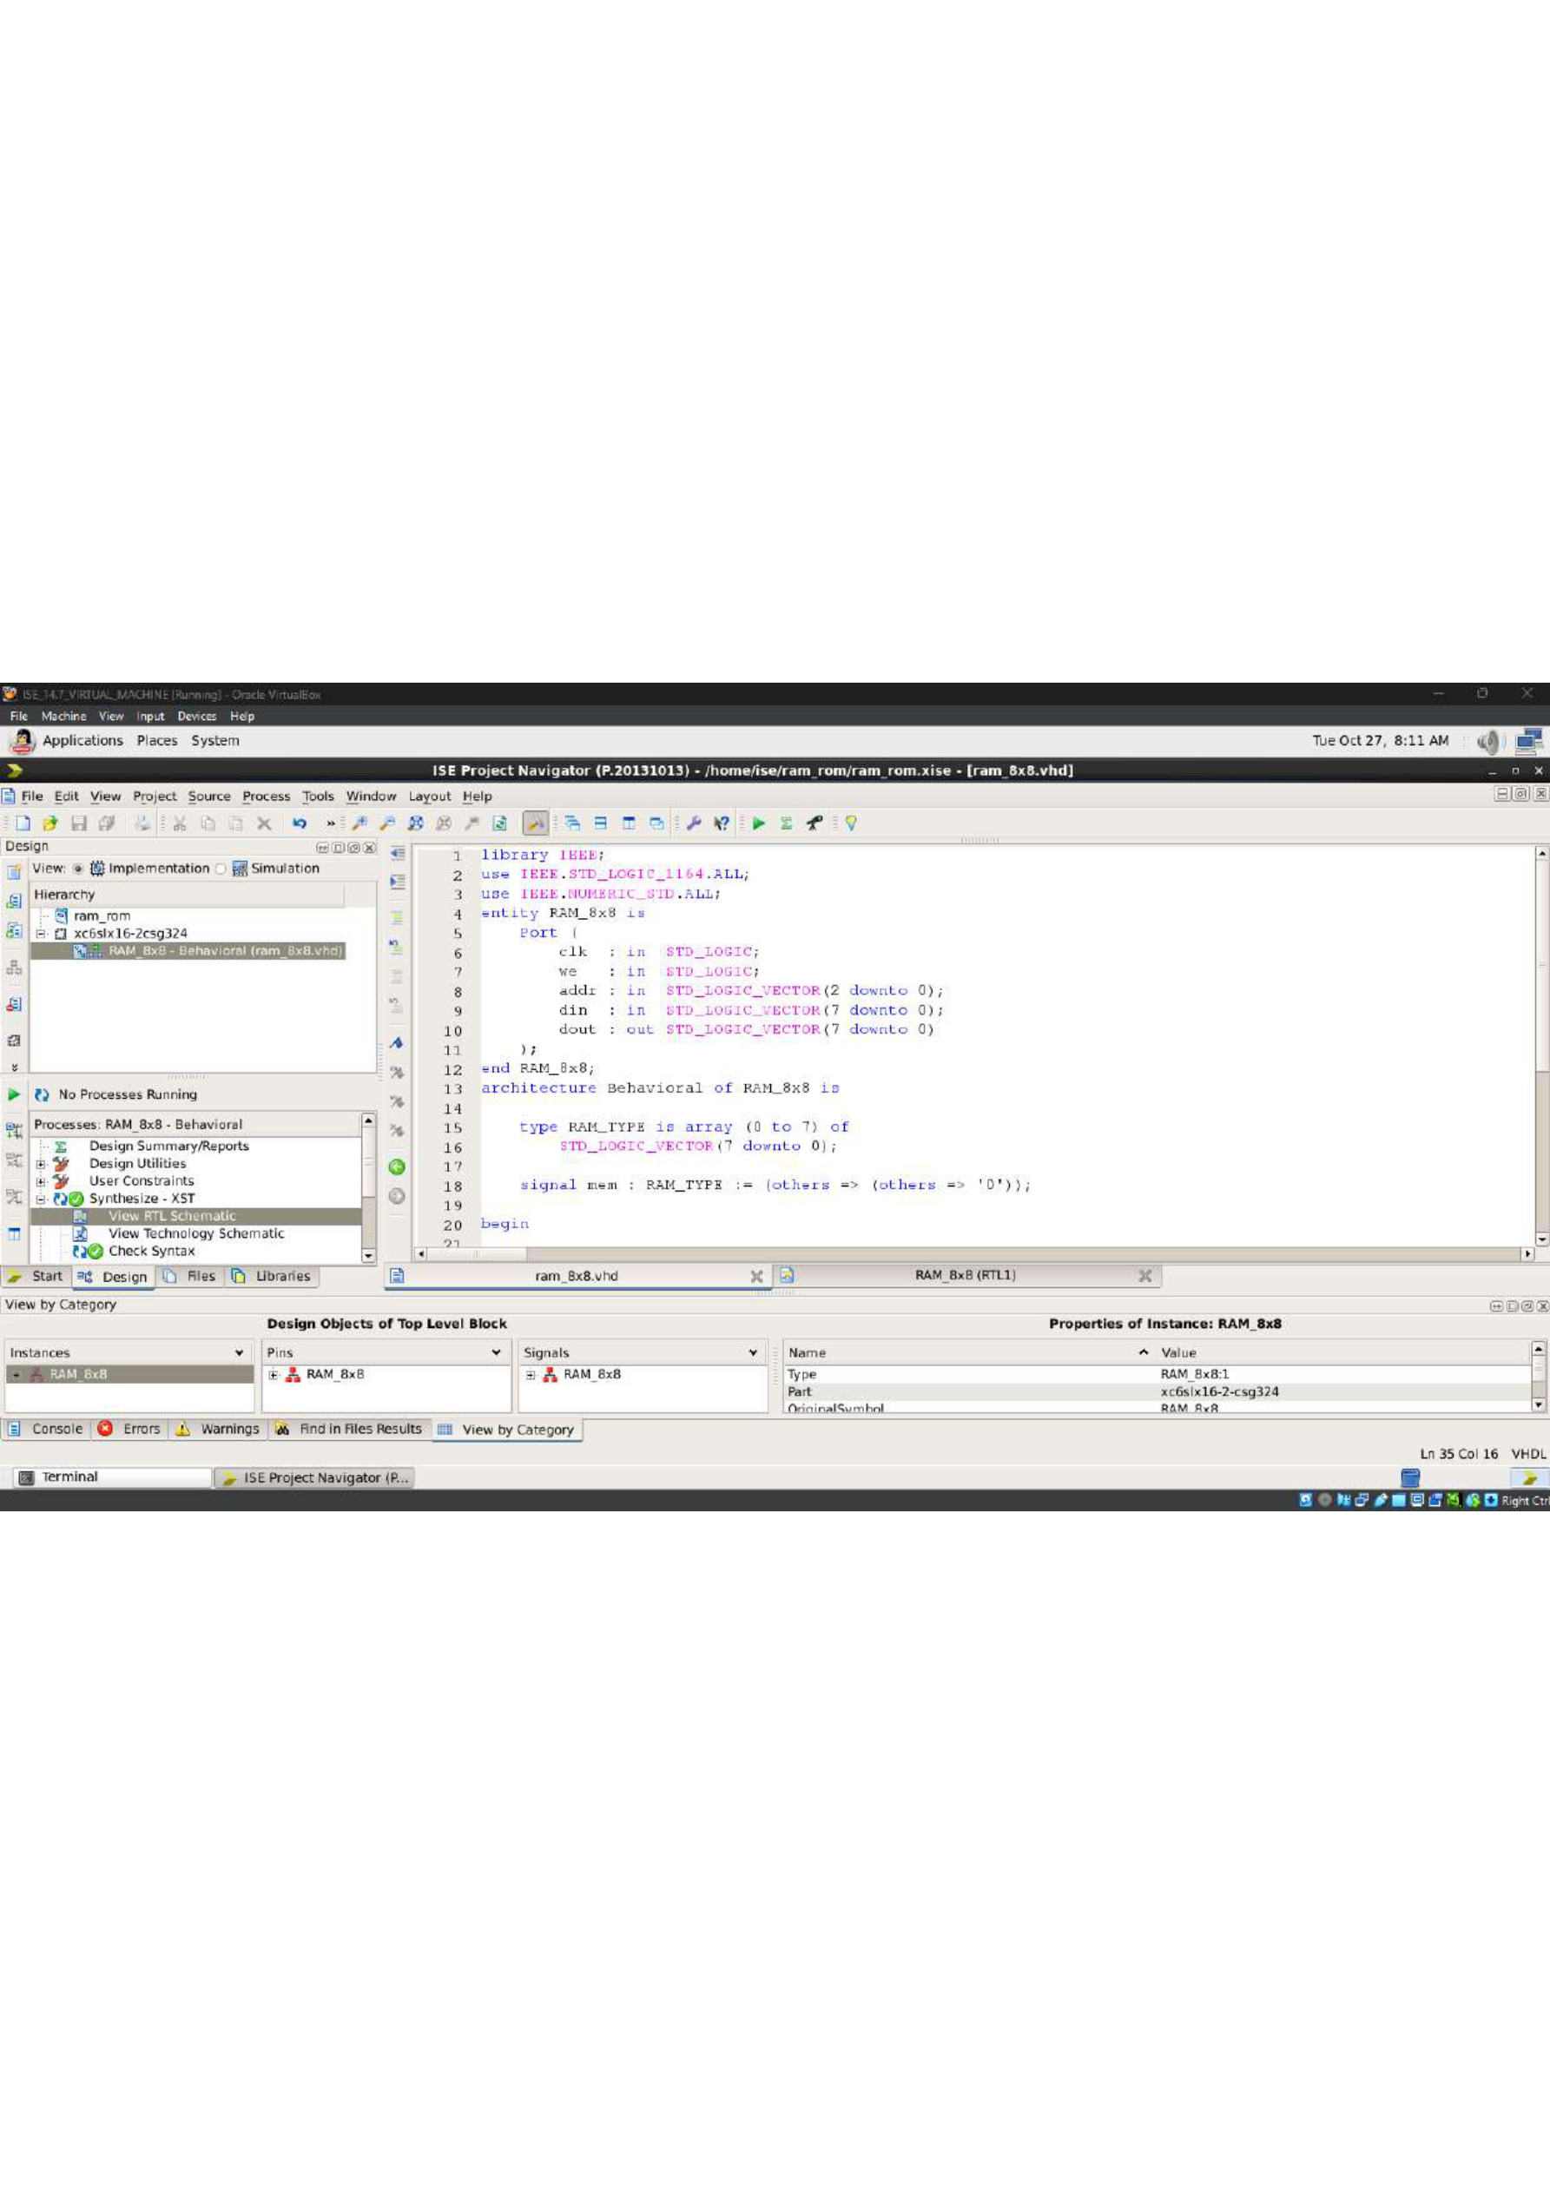

8×8 RAM — RTL Schematic
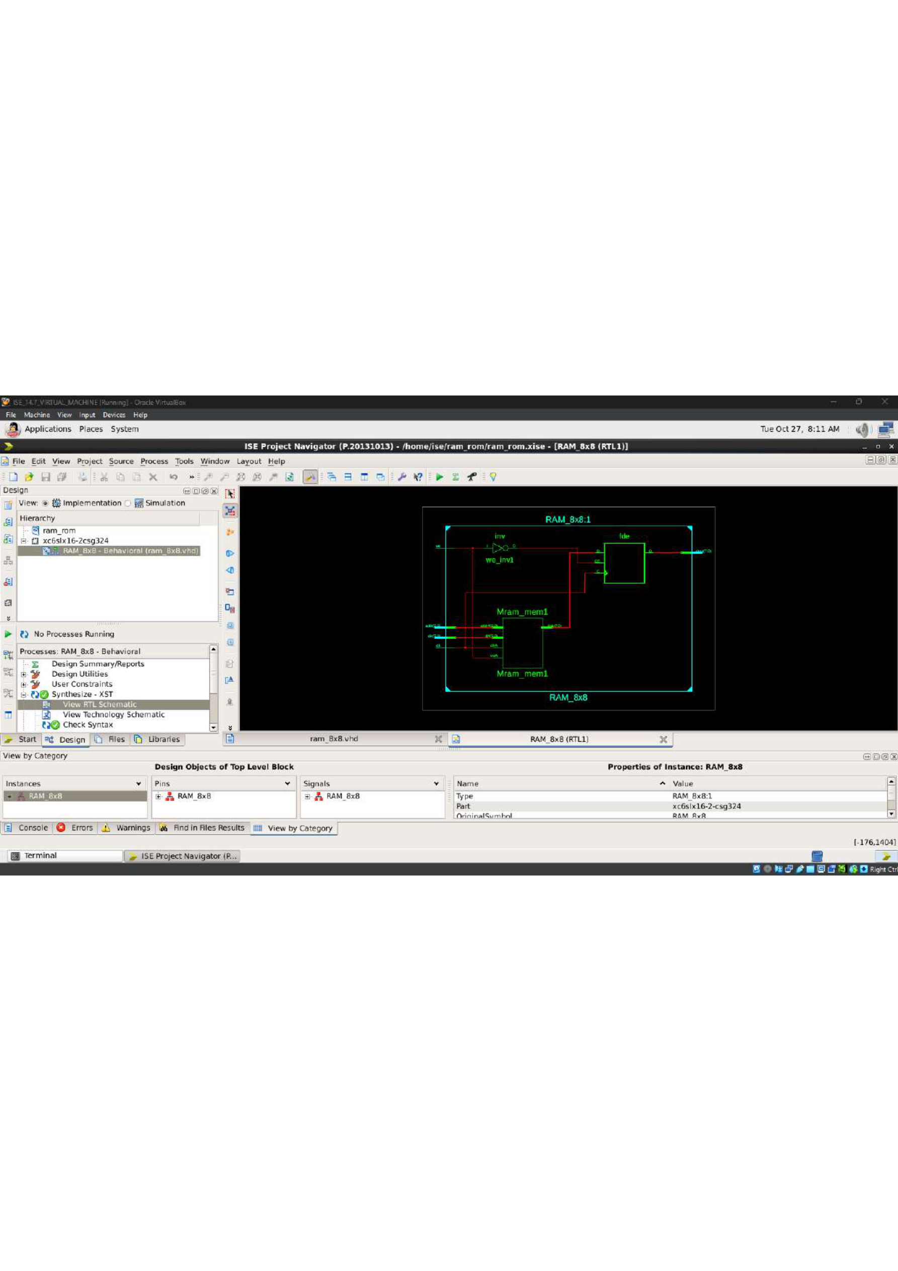

8×8 RAM — Testbench Code
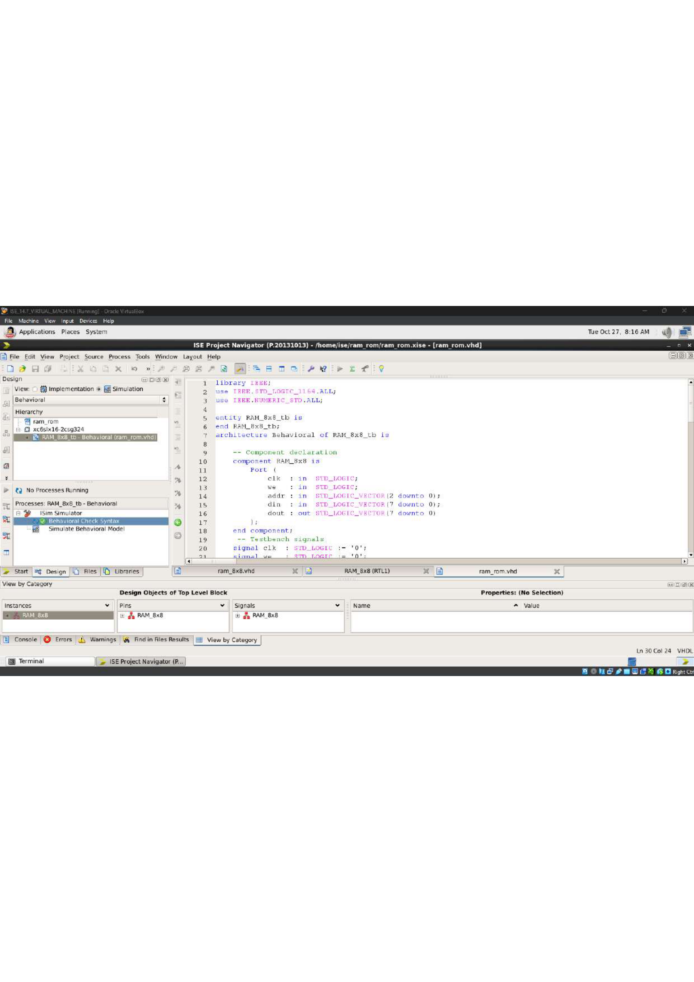

8×8 RAM — Simulation Waveform
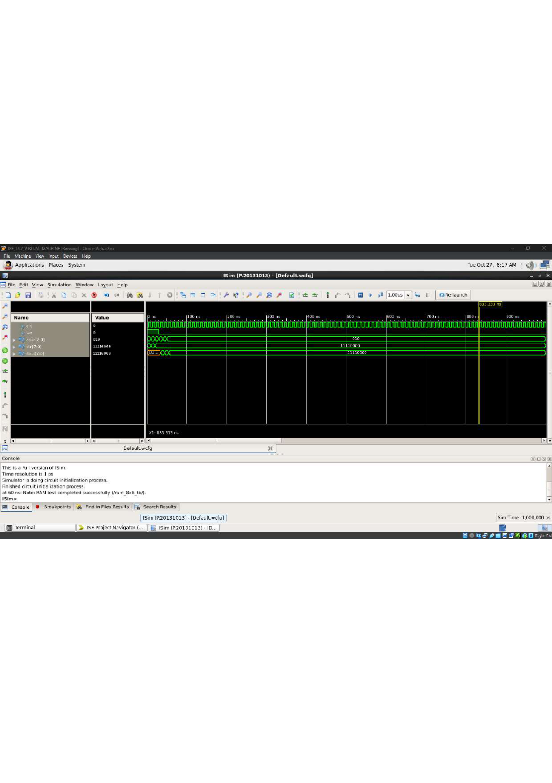

Adder / VHDL Design Screenshot — verify exact content
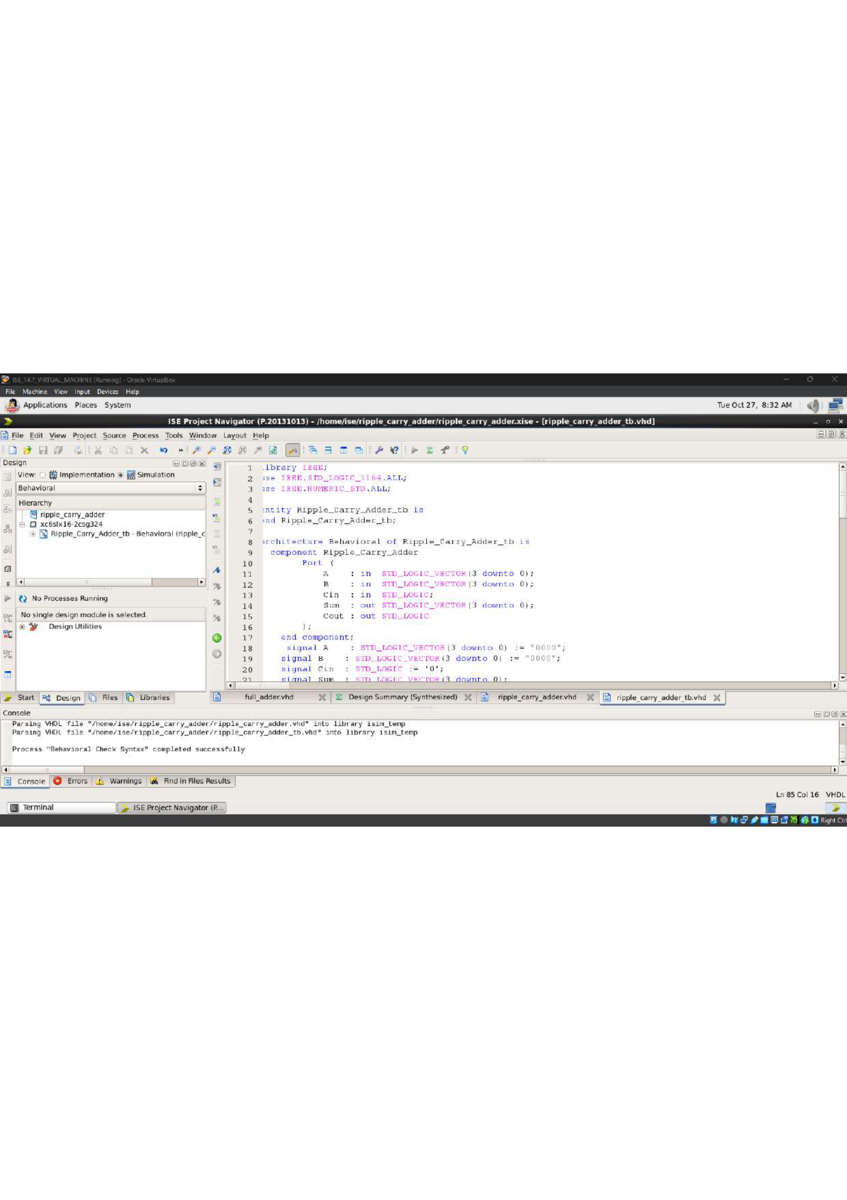

2:1 Multiplexer — RTL Schematic
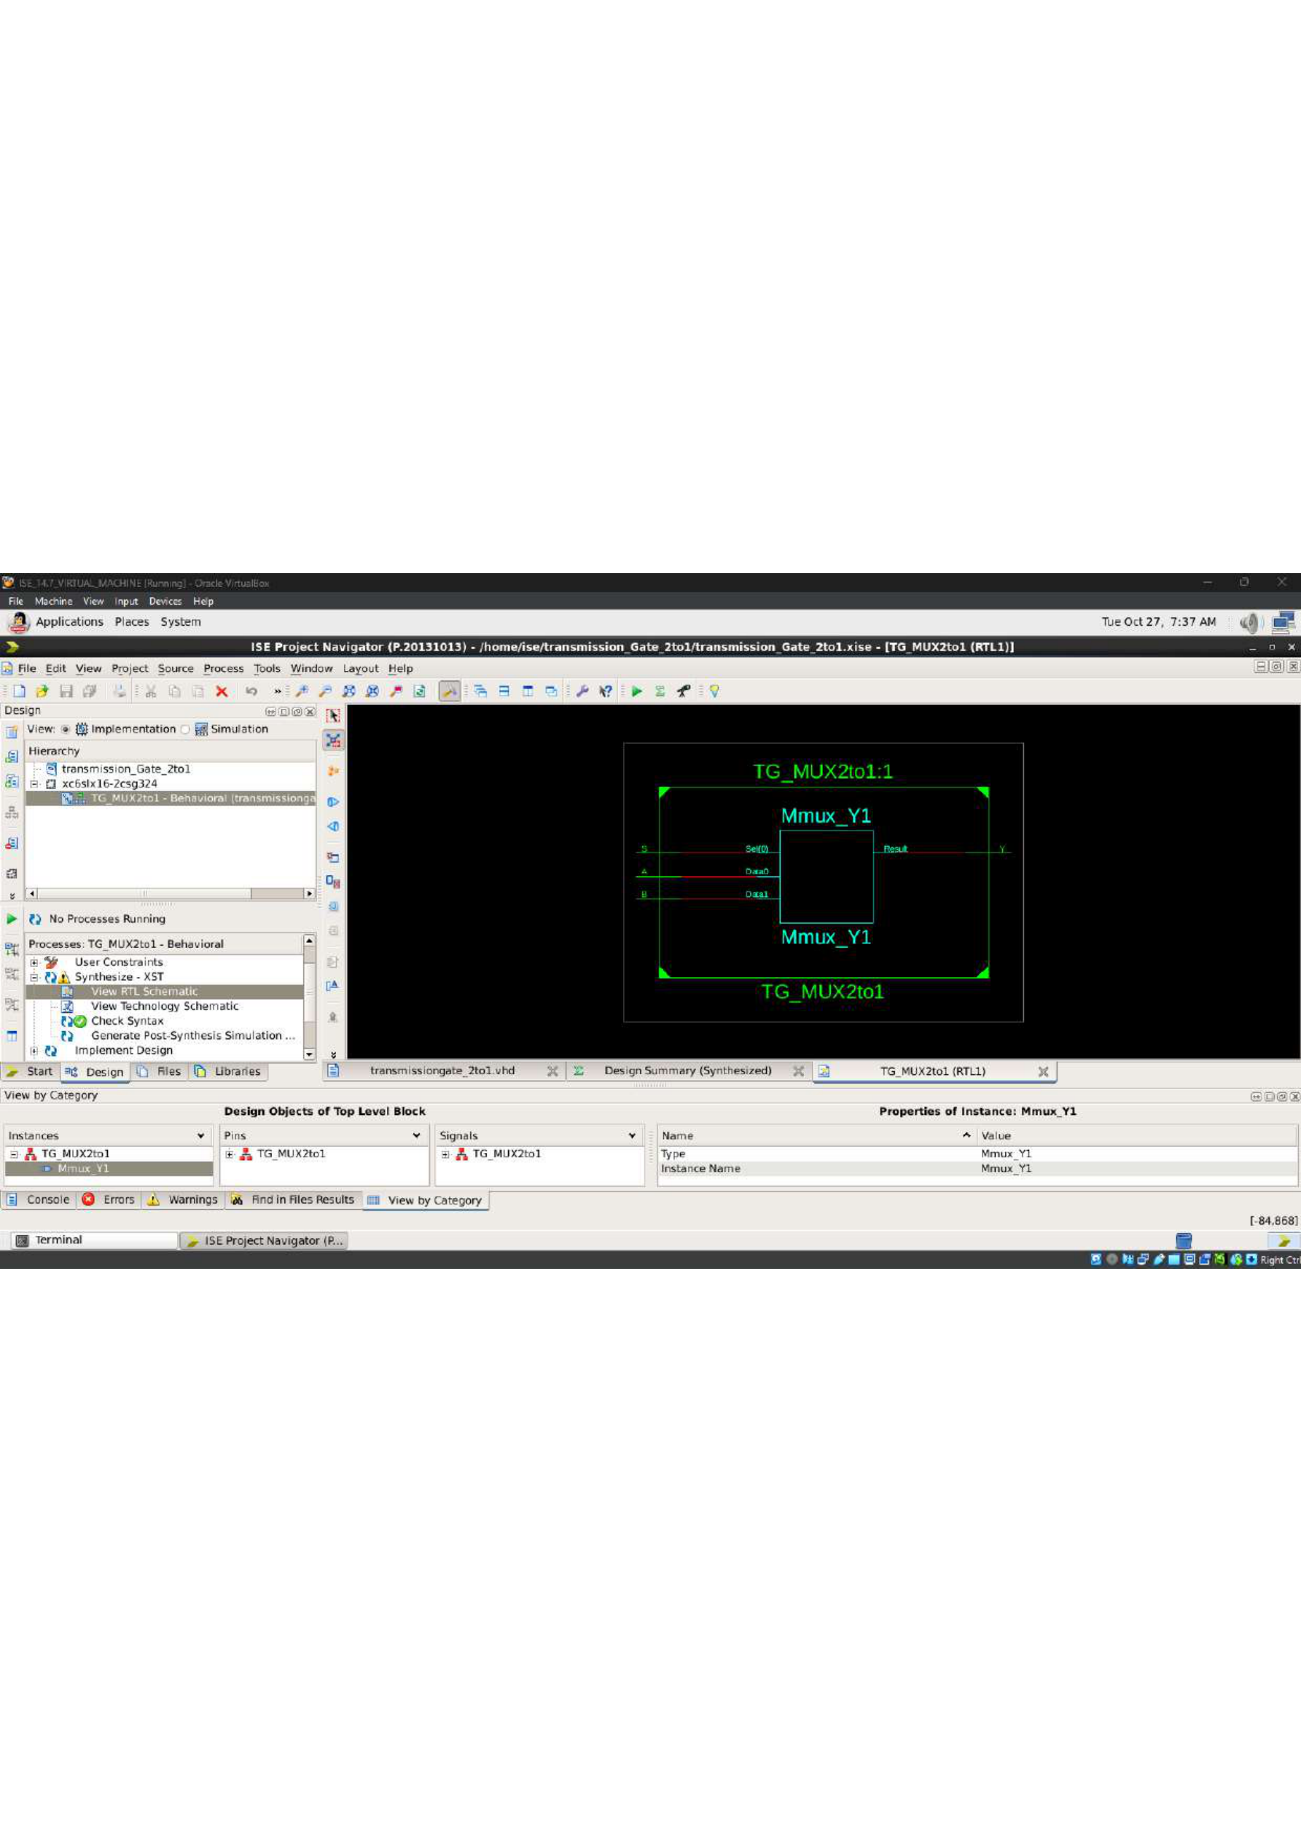

2:1 Multiplexer — VHDL Source Code
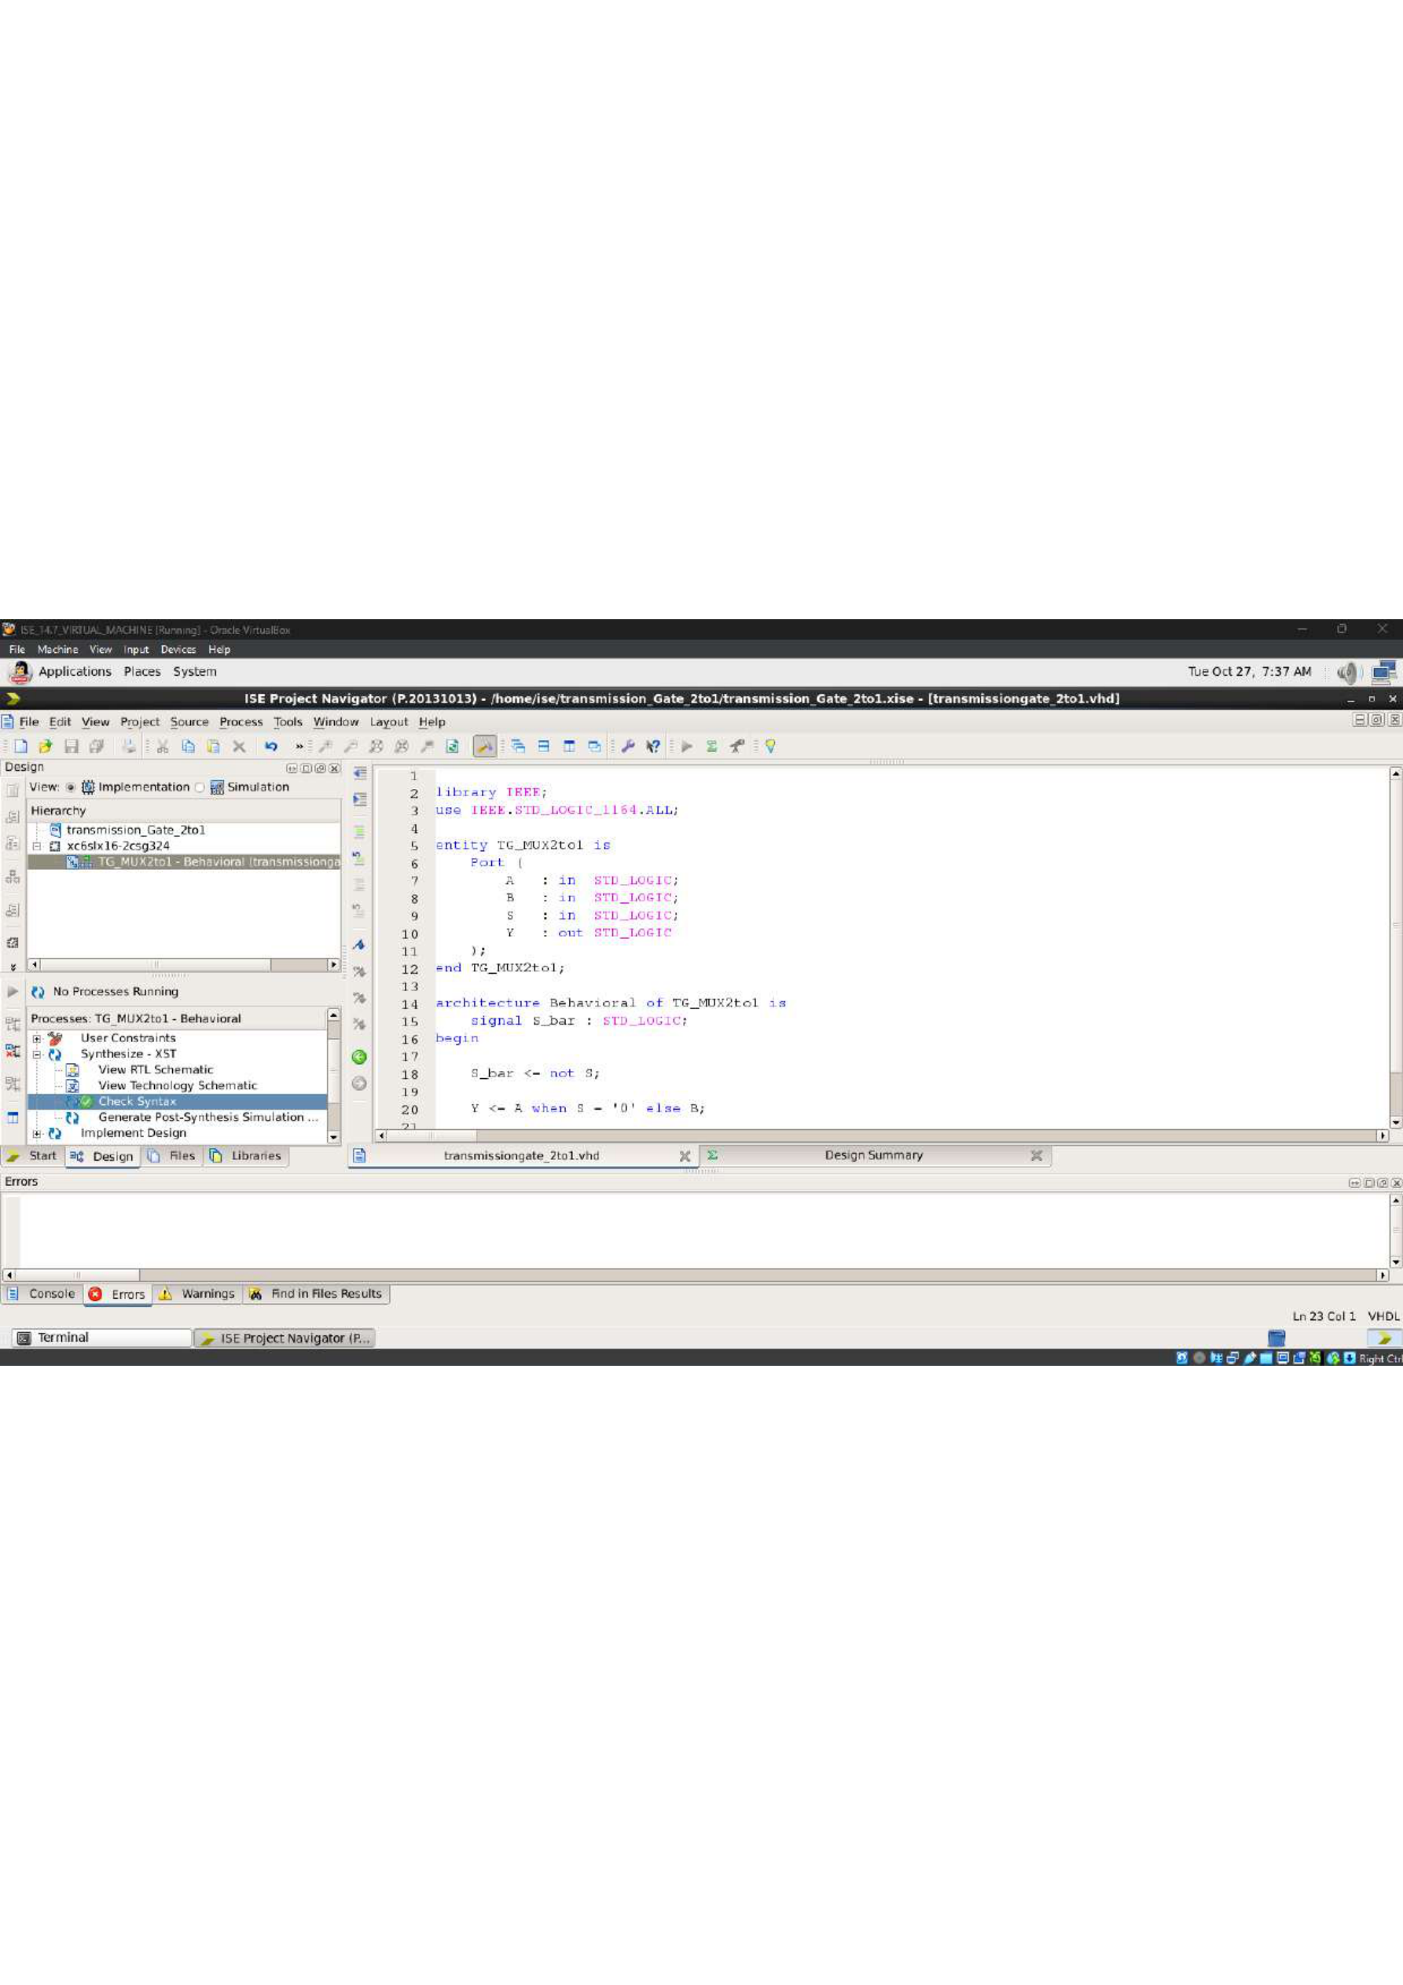

Transmission-Gate Multiplexer — VHDL / Design Screenshot
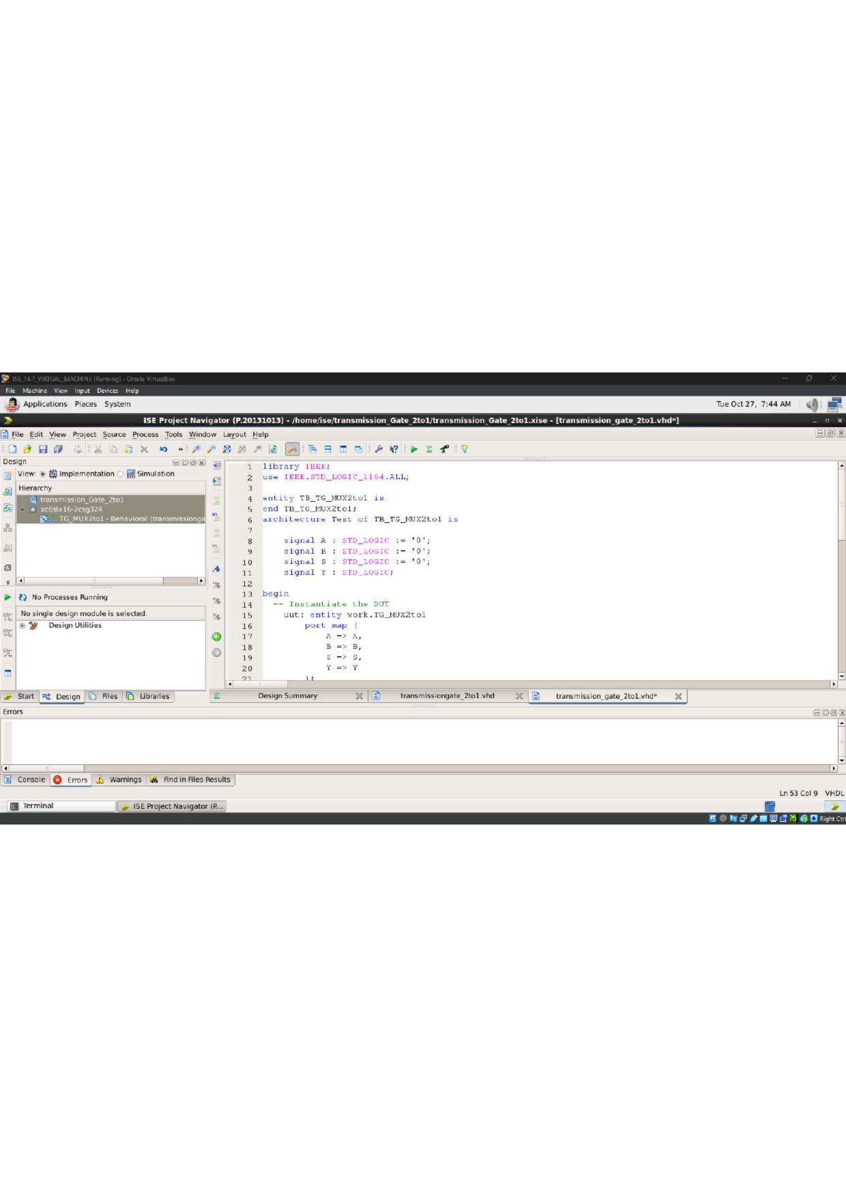

2:1 Multiplexer — Simulation Waveform


